**HORAS FLEXIVEIS – Android Studio**

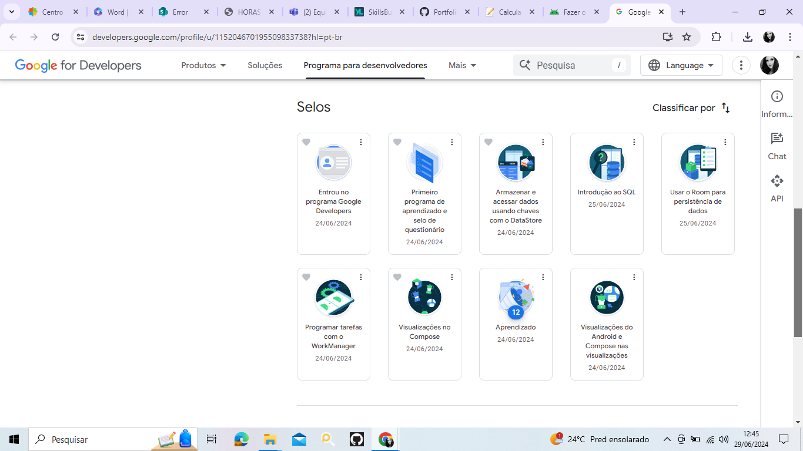

**Unit 6: Data persistence**

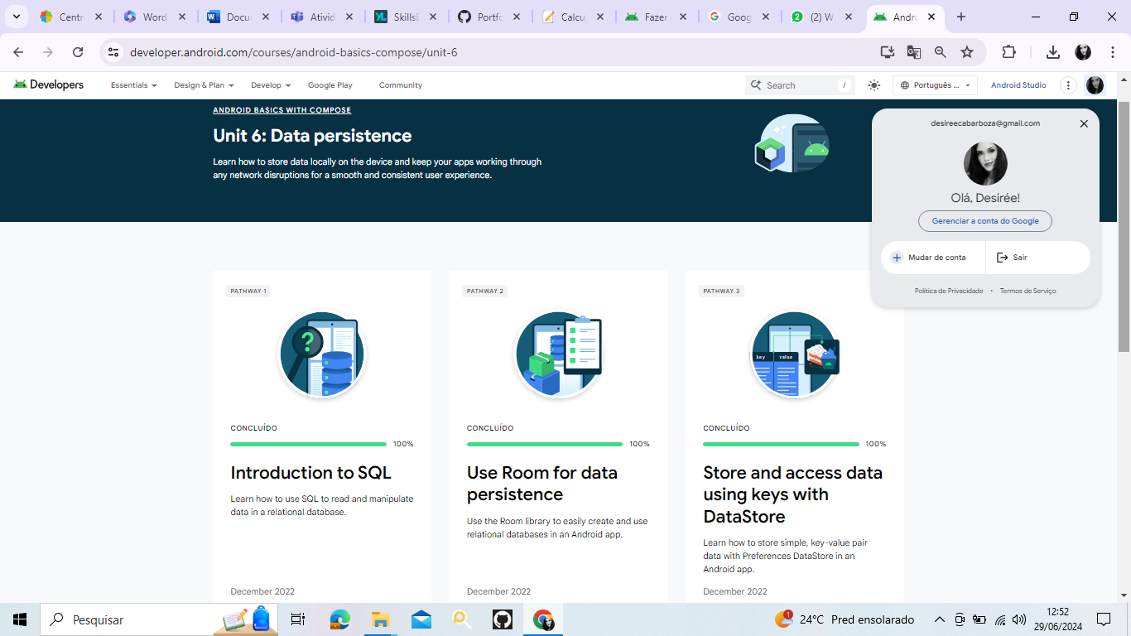

**Unit 7: WorkManager**

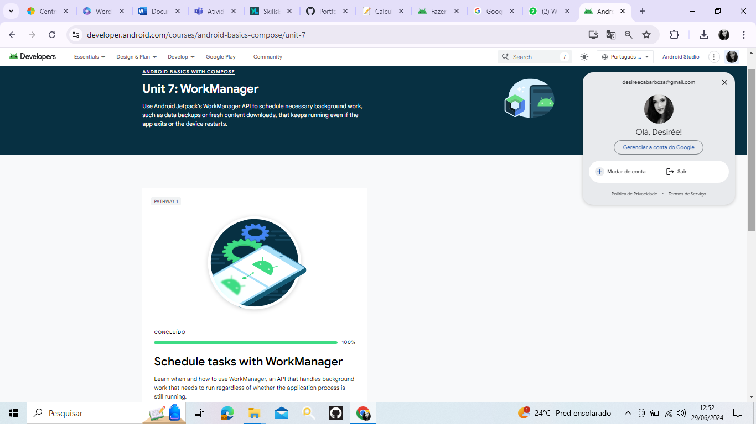

**Unit 8: Compose with Views**

